# Weather Dashboard - Use Case Report

**Student Details**

|  |  |  |
| --- | --- | --- |
| **Student Name** | **:** | E. BALA SUBASH |
| **Register Number** | **:** | 20221051516209 |
| **Institution** | **:** | JP College Of Arts And Science |
| **Department** | **:** | B.Sc (INFORMATION TECHNOLOGY) |
| **Date of Submission** | **:** | 20/03/2025 |
| **GitHub link** | **:** | https://github.com/Balasubash/weather?tab=readme-ov-file#weather |

# ProblemStatement

Weather plays a crucial role in our daily lives, impacting travel, outdoor activities, and safety. However, many existing weather applications are either overloaded with data, slow in performance, or require multiple steps to access essential information. A user-friendly and efficient weather dashboard is needed to provide real-time weather conditions and forecasts in a streamlined manner

The lack of an intuitive and lightweight weather application leads to difficulty in quickly accessing accurate weather updates. This project aims to provide a simple, fast, and effective way for users to check real-time weather data, forecasts, and search history without unnecessary complexity.

# ProposedSolution

The Weather Dashboard is a web application designed to provide real-time weather updates in a simple and user-friendly interface. The key features include:

|  |  |  |
| --- | --- | --- |
| * **Live Weather Data** | **:** | Users can enter a city name to fetch the current temperature, humidity, wind speed, and general weather conditions |
| * **Unit Toggle** | **:** | Users can switch between Celsius and Fahrenheit for temperature display. |
| * **3-Day Forecast** | **:** | Displays upcoming weather conditions to help users plan ahead. |
| * **Search History** | **:** | Saves the last five searched cities for quick access |
| * **Minimalist UI** | **:** | Ensures a smooth and hassle-free experience |

This solution leverages the **OpenWeather API** to dynamically retrieve real-time weather dataand updates.

# Technologies & Tools Considered

* + **Frontend Technologies :** HTML, CSS, JavaScript
  + **API Used:** Open Weather API
  + **Storage:** Local Storage for storing search history
  + **Version Control:** Git/GitHub form an aging project files
  + **Hosting:** GitHub Pages, Netlify, or similar deployment platforms

# Solution Architecture & Workflow

## System Work flow:

1. The user enters a city name into the search bar.
2. The application fetches weather data from the **OpenWeather API**
3. The retrieved data is processed and displayed, including temperature, humidity, wind speed, and conditions.
4. The search history is updated in **LocalStorage**.
5. The user can toggle the temperature unit between Celsius and Fahrenheit.
6. The user can revisit past searches via the stored history

## System Components:

* Frontend UI: The interface built using HTML and CSS for a smooth user experience.
* JavaScript Logic: Handles API calls, data processing, and DOM manipulation.
* External API (OpenWeather): Fetches real-time weather updates and forecasts.
* LocalStorage: Stores search history data.

# 

# Feasibility & Challenges

## Feasibility:

* The project is feasible as it relies on standard web technologies and a freely available API.
* It is lightweight and requires minimal computing resources.
* Can be deployed on free hosting services like GitHub Pages or Netlify.

## Challenges & Solutions:

* + **APILimitations:**Free-tierOpenWeatherAPIhasratelimits.Implementingcaching mechanisms can optimize requests.
  + **UserExperience:**EnsuringresponsivenessandacleanUIiskeytousability.Using CSS frameworks like Bootstrap can improve design.
  + **PerformanceOptimization:**ReducingunnecessaryAPIrequestsandpreloading frequently searched cities can enhance performance.

# Expected Outcome & Impact

## Expected Benefits:

* Provides an easy and quick way to check real-time weather conditions.
* Helps users make informed decisions about their day.
* Reduces reliance on complex weather websites with excess information.
* Saves user time with search history storage.

## Target Users:

* General Users: Anyone looking for quick weather updates.
* Travelers & Commuters: Plan their trips based on weather conditions.
* Outdoor Enthusiasts: Hikers, bikers, and event planners.
* Professionals: Farmers, logistics teams, and emergency responders.

# Future Enhancements

* Extended Forecast: A 7-day forecast for better long-term planning.
* Geolocation Feature: Automatically fetch weather updates based on user location.
* Air Quality Index (AQI): Display pollution levels alongside weather data.
* Dark Mode: Implement a dark mode for better accessibility.
* Weather Alerts: Notify users about severe weather conditions.

# Conclusion

The Weather Dashboard project addresses the need for a simple, fast, and efficient way to access real-time weather data. With features like live weather updates, a 3-day forecast, and search history, it provides users with accurate and relevant information without overwhelming them with unnecessary details. By leveraging the OpenWeather API and using LocalStorage to save search history, the application offers a streamlined and personalized user experience.

The project is feasible with widely available technologies, and its lightweight nature ensures minimal resource usage. Challenges, such as API rate limits, are mitigated through caching mechanisms, and performance is optimized by preloading frequently searched cities. Future enhancements like a 7-day forecast, geolocation, and weather alerts will further enhance its functionality.

Overall, the Weather Dashboard is an accessible, efficient, and user-friendly tool that helps users make informed decisions based on real-time weather data, making it a valuable application for a wide range of users.

**Screenshot:**

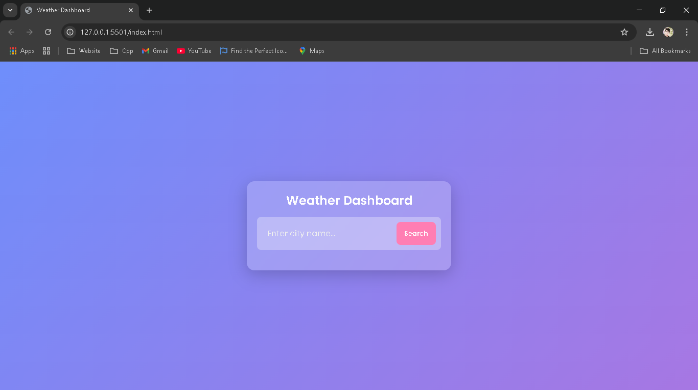

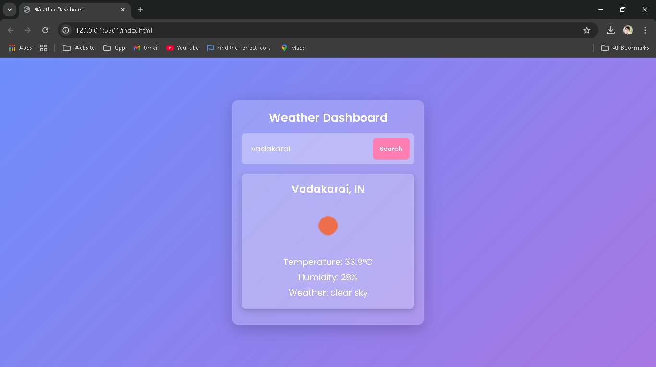

This report outlines the **Weather Dashboard** project, highlighting its problem statement, proposedsolution,technicalstack,feasibility,andfutureimprovements.Theprojectaimsto deliver an intuitive and practical weather application to benefit users by providing real-time weather information effortlessly.